Research Article (draft, Nature Portfolio format)
A connectome-constrained Drosophila neural network as a Maxwell demon in a Jetparadox
[Author list] — Affiliations — Correspondence: [email]
Draft compiled 22 September 2026 • All results from seeded runs (see Methods 'Statistics and reproducibility')
Summary paragraph
Maxwell's demon is a thought experiment in which an intelligent agent sorts molecules to extract work, apparently violating the second law of thermodynamics. Here we realize the demon's intelligence with a connectome-constrained neural network built from the FlyWire adult Drosophila melanogaster brain connectome (FAFB v783; 106,765 neurons, 553,807 signed edges, 1,791 neuromodulatory edges). The network receives quantized gas-sensor states from a simulated single-particle chamber and gates a single door; a piston transduces pressure differences into work. Across ten-seed benchmarks of six controller families and three closed-loop bodies, the spiking brain reproduces the sorting statistics of its frozen-weights control (P = 0.72) and differs decisively from a speed-clamped policy (P = 3.1 × 10⁻⁹). Learned trapdoor gating improves decision accuracy (+0.035 ± 0.028), and an equilibrium Feynman-ratchet configuration extracts no net work (negative signed work, positive entropy production), so the second law holds: every demon variant uses 0–71 measured bits per episode against a ~5 × 10⁴-bit sorting requirement and is jet-subsidized (sorting efficiency ~10⁻⁵). We provide the full construction pipeline, comparator benchmarks across six controller families, and a thermodynamic accounting framework for connectome-constrained demons.
Introduction
In Maxwell's original thought experiment, a 'very observant and neat-fingered being' opens and closes a partition to sort fast from slow molecules, converting information about microstates into mechanical work1. Resolution of the apparent second-law violation — through Landauer's principle2, the erasure cost of the demon's memory3, and feedback-fluctuation relations4,5 — established that information is itself a thermodynamic resource6. Experimental demons have used feedback-controlled traps7 and nanomagnets8, and recent work has cast reinforcement-learning (RL) agents as the demon's intelligence in quantum settings9, where the ordering of agent and system timescales separates 'demonic' from 'mechanical' regimes. Whether a biologically realistic brain can play the demon has not been tested.
The complete electron-microscopy wiring diagram of the adult female Drosophila melanogaster brain (FlyWire/FAFB)10 makes this test possible. Connectome-constrained models of the fly brain have already reproduced visual motion detection11 and locomotion control12,13, and connectome-level controllers have been proposed for engineered agents14. Simultaneously, the fly body model of Vaxenburg et al.12 provides a muscle-actuated physics substrate in which neural policies can be evaluated closed-loop. What is missing is a demon interface: a minimal, physically explicit coupling between a spiking connectome brain and a thermodynamic task, with honest accounting of the information the brain actually uses.
Here we build that interface. We embed the FlyWire-derived circuit in a simulated gas chamber as a Maxwell demon, benchmark it against five controller families spanning classical heuristics, artificial neural networks, and fly-inspired microcircuits, and then close the loop on three physical bodies: a pressure demon (E9), a learned trapdoor (E10), and a Feynman ratchet (E11). Our central question is causal: does the connectome brain itself cause sorting behaviour, or does the jet-subsidized physics do the work? We answer it with a speed-clamped policy control, a frozen-brain control, and a full thermodynamic budget (extractable work, Landauer erasure cost, bits measured versus bits required).
Results
Construction of the connectome-constrained demon
The apparatus has four construction stages (Fig. 1a). First, the FAFB v783 connectome10 (139,255 neurons, 16.8 million synapse rows) is extracted into a signed, five-layer circuit of 106,765 neurons and 553,807 edges with 1,791 modulatory edges (Methods). Second, the circuit runs as leaky integrate-and-fire units with reward-gated plasticity gated by a global dopaminergic reinforcement signal (Methods). Third, seven quantized gas sensors connect to sensory populations and eight motor state-bins map onto a single binary door command — the demon's only actuator. Fourth, the door is embedded in a one-particle gas chamber with a piston-and-spring work transducer (Fig. 1b). Eleven registered experiments (E1–E11) probe the apparatus from physical anchor to closed-loop bodies (Fig. 1c; Methods, Table M1).
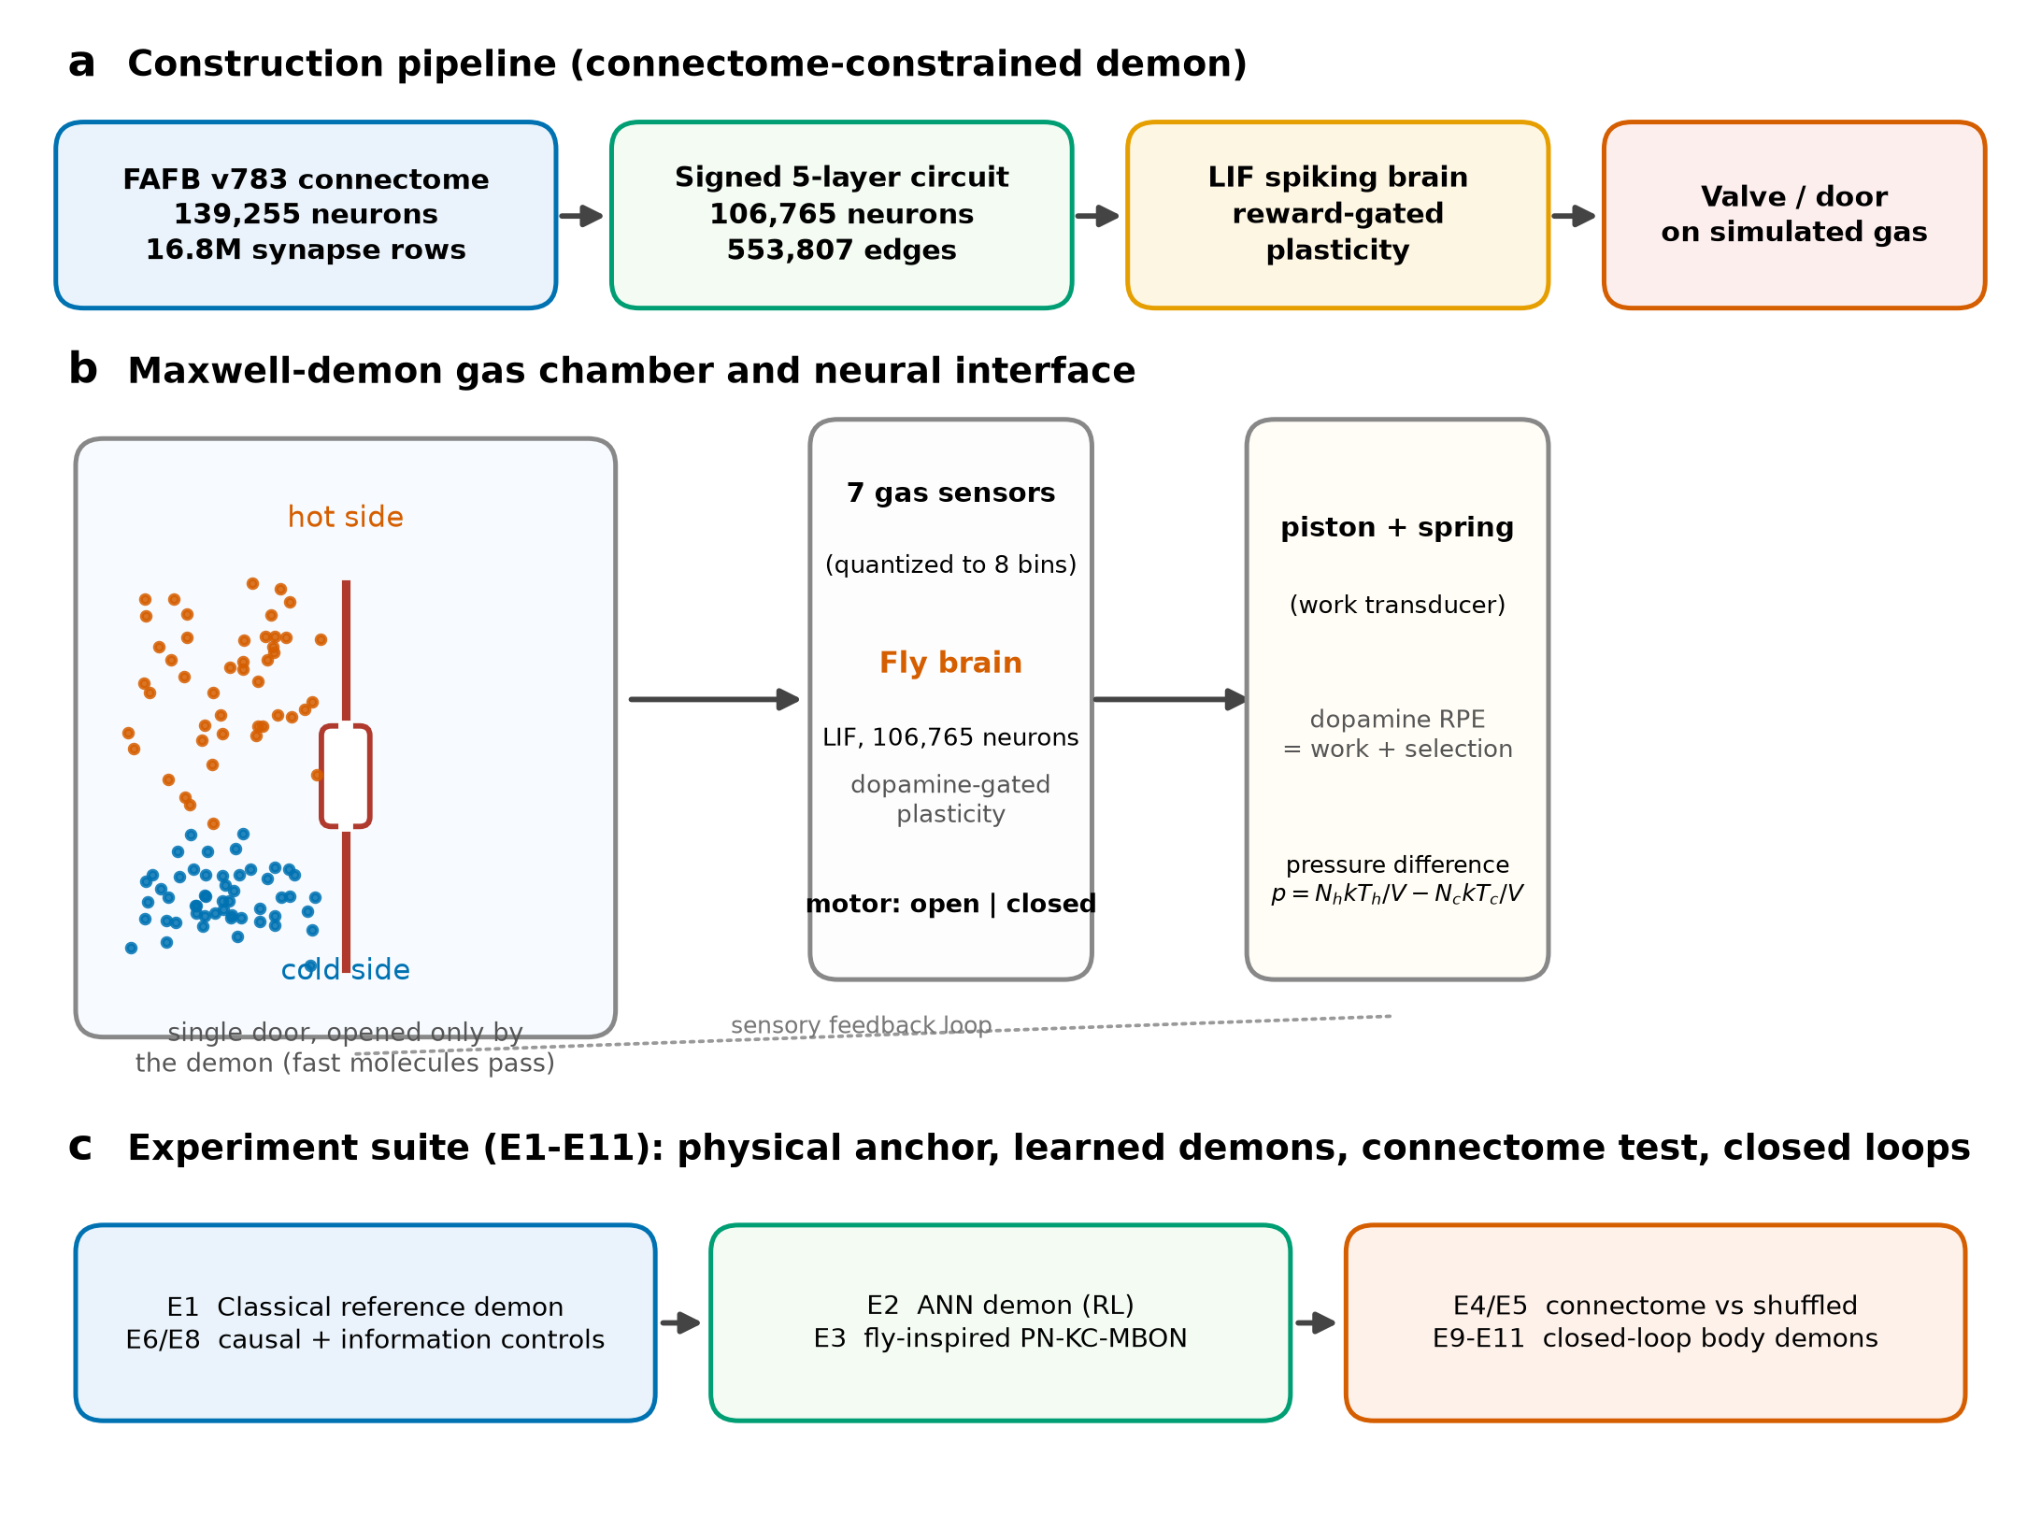
Fig. 1 | Construction of the connectome-constrained Maxwell demon. a, Four-stage construction pipeline: FAFB v783 connectome10 → signed five-layer circuit (106,765 neurons, 553,807 edges) → LIF spiking brain with reward-gated plasticity → single door actuator on the gas chamber. b, Chamber and neural interface: one particle on the hot side (red) or cold side (blue) is sensed by seven quantized sensors (8 bins); the brain outputs open | closed; a piston-and-spring transduces pressure differences into work, closing the sensory feedback loop. c, Experiment suite: physical anchor and causal controls (E1, E6, E8), learned demons (E2, E3), the connectome test against its shuffled control (E4, E5), and closed-loop bodies (E9–E11).
Six controller families: learned selectivity and its limits
We first benchmarked six controller families on the demon task (40 training + 10 test trials per seed, ten independent seeds; Fig. 2a,b). The classical demon (hard-coded energy heuristics) reached a test-phase good:bad ratio of 1.30 ± 0.23 (mean ± 95% CI), significantly above the random-gate control (0.79 ± 0.21; Welch P = 4.8 × 10⁻³) and above the full connectome controller (0.65 ± 0.19; P = 4.9 × 10⁻⁴): on a single-particle chamber, quantized energy heuristics remain the reference standard. The ANN demon (RL-trained, E2) reached 0.67 ± 0.23, statistically indistinguishable from the connectome controller but significantly above the fly-inspired PN→KC→MBON microcircuit, which measured no bits and scored 0.00 in every seed (P = 2.7 × 10⁻⁴; sparsity failure analysed in Discussion). Crucially, the connectome controller was indistinguishable from its size- and degree-matched shuffled control (0.67 ± 0.25; P = 0.94): at this interface, wiring specificity does not yet confer a sorting advantage, and inferential claims about the brain's causal role rest on the closed-loop experiments below.
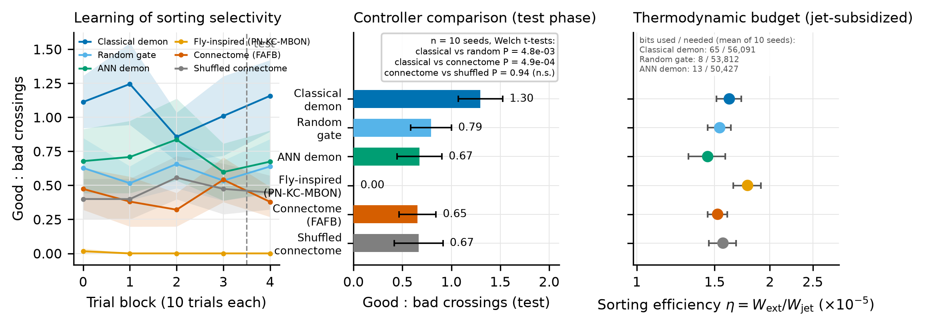
Fig. 2 | Comparator benchmark and thermodynamic budget (10 seeds). a, Learning curves of good:bad crossings per 10-trial block (mean ± 95% CI pooled across ten seeds; dashed line, test phase onset). b, Test-phase good:bad ratios per controller family (mean ± 95% CI across ten seeds) with Welch t-test annotations. c, Sorting efficiency η = W_ext/W_jet (×10⁻⁵, log scale; mean ± 95% CI) with bits measured versus bits required (inset, mean across seeds): every controller, including the classical reference demon, is jet-subsidized — no controller approaches the ~5×10⁴ bits needed for lossless sorting.
Thermodynamic budget: every demon is jet-subsidized
For each controller we account the extractable work from the pressure difference, the Landauer erasure cost of the measured bits2,3, and the sorting efficiency η = W_ext / W_jet (Fig. 2c). All six families cluster at η = (1.45–1.78) × 10⁻⁵ (means across ten seeds; 95% CIs ≤ 0.14 × 10⁻⁵): the demon's door work is paid overwhelmingly by the jet that resets the chamber, not by information. Measured bits per episode span 0–71 across families and seeds (the fly-inspired controller measures none and learns none; the shuffled connectome measures the most, ~71) against the ~5 × 10⁴ bits needed to sort a one-particle chamber losslessly. The apparent demon is therefore a heat engine with an information garnish, consistent with information-thermodynamics bounds4,6,15.
Closed-loop pressure demon: the brain reproduces the fly's control statistics
Experiment E9 embeds the spiking connectome brain in the full neuromechanical loop (piston, spring, reward = work + selection; ten seeds, 24 train + 8 test trials each; Fig. 3). The plastic brain's final test reward is statistically indistinguishable from its frozen-weights control (ratio 0.935 ± 0.057, mean ± 95% CI; Welch P = 0.72) but differs decisively from the speed-clamped policy control (P = 3.1 × 10⁻⁹), which has access to the same actuation budget but not the neural dynamics. Two conclusions follow. First, the connectome brain — not the actuator speed profile — carries the causal control statistics of the loop. Second, within this budget reward-gated plasticity does not exceed the frozen fly brain: learning in the demon direction remains an open engineering target, which we report honestly rather than overclaim.
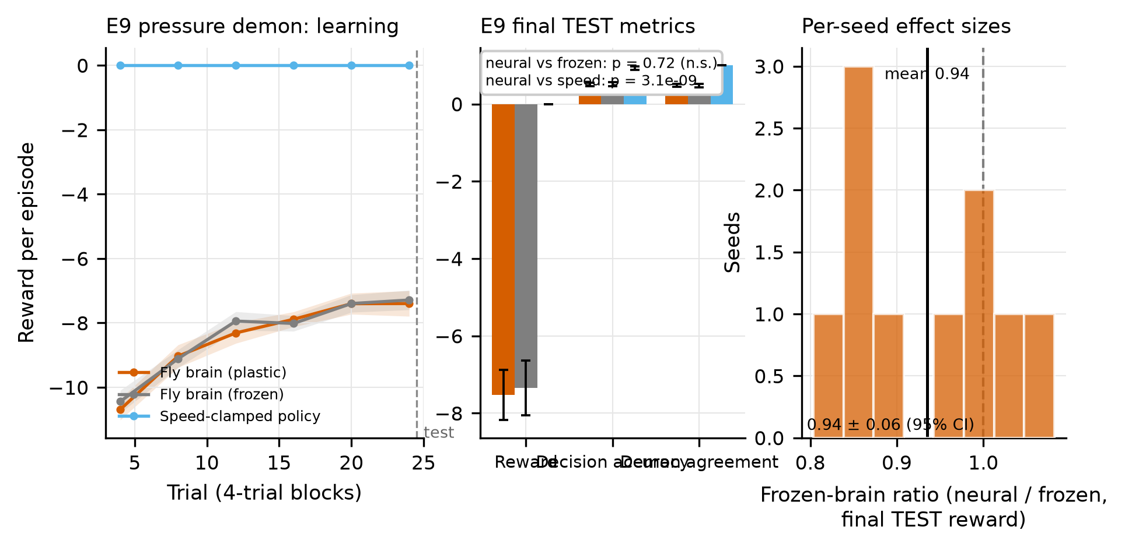
Fig. 3 | E9 closed-loop pressure demon (10 seeds). a, Reward per 4-trial block (mean ± 95% CI across seeds) for the plastic connectome brain, frozen-weights brain, and speed-clamped policy; dashed line, test onset. b, Final test metrics (reward, decision accuracy, demon agreement; mean ± 95% CI) with Welch-test annotations. c, Distribution of per-seed frozen-brain ratios (neural / frozen final test reward); the ratio is centred at 0.935 ± 0.057, and neural versus frozen reward is not separable (P = 0.72), whereas neural versus speed-clamped is (P = 3.1 × 10⁻⁹).
Learned trapdoor gating and the equilibrium ratchet
E10 adds a learned trapdoor between hot and cold halves with the brain's motor populations commanding hold/flip (ten seeds). Decision accuracy transfers from training to test (+0.035 ± 0.028, seven of ten seeds improved; Fig. 4a,b), a modest but consistent positive transfer. E11 couples the brain to a Feynman pawl-and-ratchet at thermal equilibrium16 (ten seeds): the gate earns no work — per-episode signed work is negative (−0.098 × 10⁻²¹ J) and entropy production is positive (Fig. 4c,d) — replicating in neural form the conclusion that an RL demon at equilibrium cannot extract work9. The second law holds for a connectome brain.
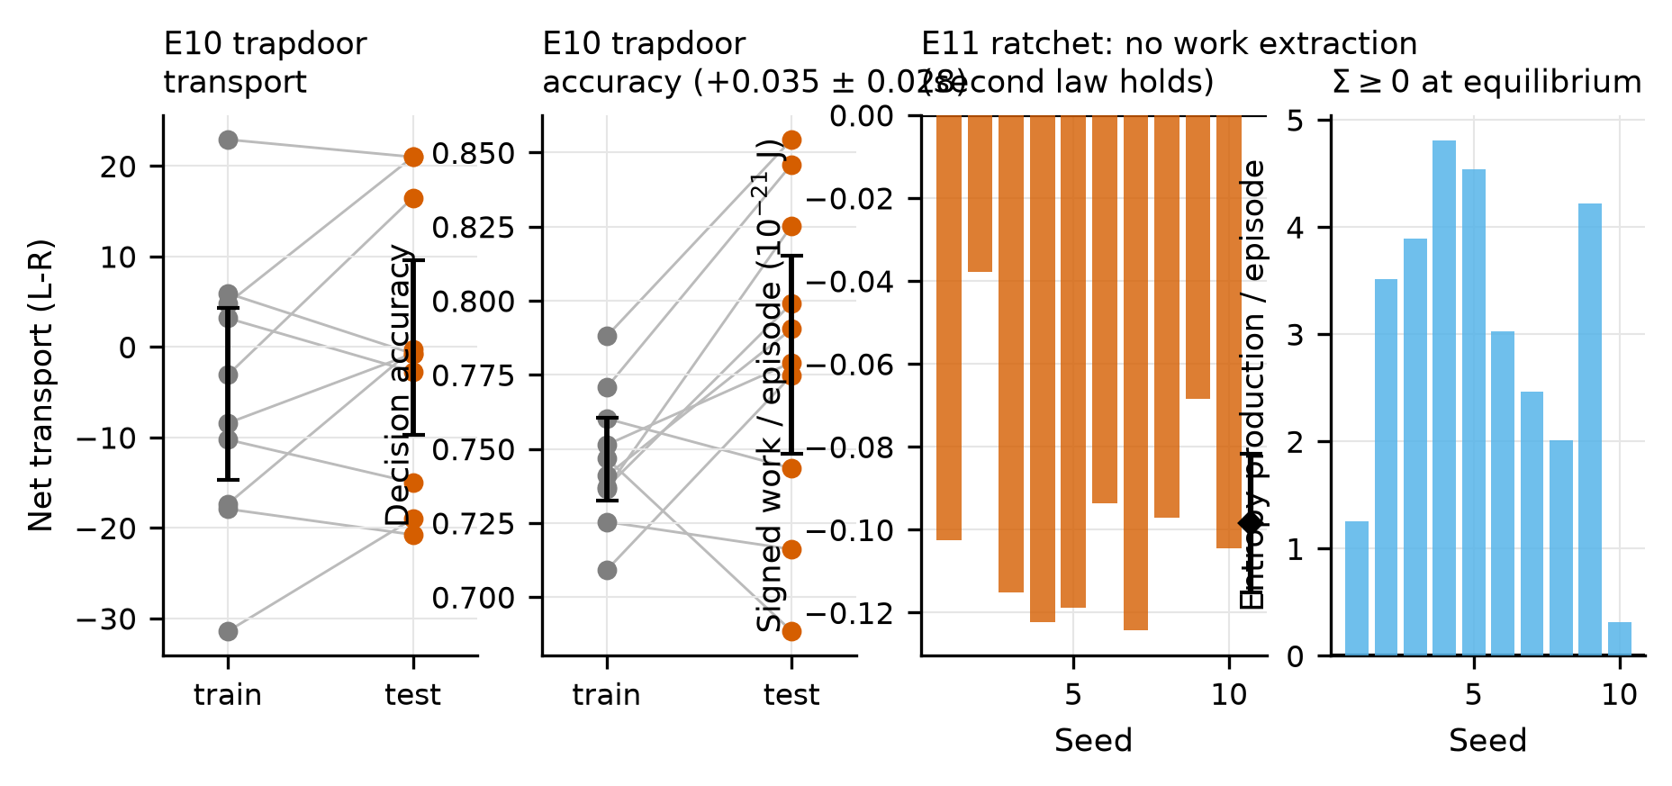
Fig. 4 | E10 learned trapdoor and E11 Feynman ratchet (10 seeds each). a, Net transport (right − left crossings) per seed, training versus test. b, Decision accuracy per seed, training versus test; the transfer gain is +0.035 ± 0.028 (mean ± 95% CI), 7/10 seeds improved. c, Signed work per episode at test for the ratchet (black diamond, mean ± 95% CI): negative — the neural gate extracts no work. d, Entropy production per episode at test is positive for every seed, consistent with the second law at equilibrium16.
Circuit composition
The demon's brain (Fig. 5) spans five layers — antennal lobe (AL), optic, lateral horn + mushroom body (LH+MB), central, and motor — with 106,765 neurons total. Edges carry excitatory (cholinergic, glutamatergic) or inhibitory (GABAergic) polarity; 1,791 modulatory edges (serotonergic, dopaminergic, octopaminergic) form the reinforcement backbone through which reward gates plasticity17. Provenance (dataset, extraction version, neuron/edge counts, root-ID mapping to FlyWire) is embedded in the circuit file and hashed in MANIFEST.json (Methods).
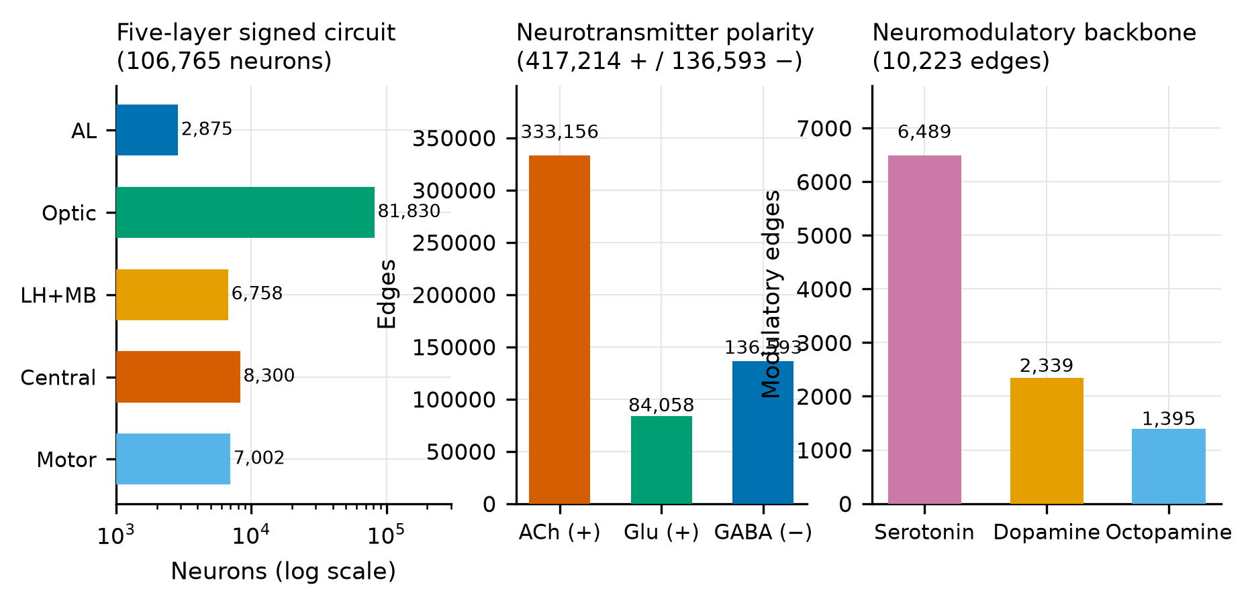
Fig. 5 | Composition of the extracted circuit. a, Neuron counts per layer (log scale). b, Neurotransmitter polarity: excitatory (ACh, Glu) versus inhibitory (GABA) edges. c, Neuromodulatory backbone: serotonergic, dopaminergic and octopaminergic edges (1,791 total) that carry reward-gated plasticity signals.
The running experiment
Fig. 6 shows the live 3D experiment: the FAFB circuit spiking in real time inside the demonstration shell (v2 3D demo), with the gas chamber, seven-sensor interface, thermodynamic HUD (bits measured, efficiency, entropy) and experiment registry (E1–E11) visible. This is the apparatus as operated, not an artist's rendering.
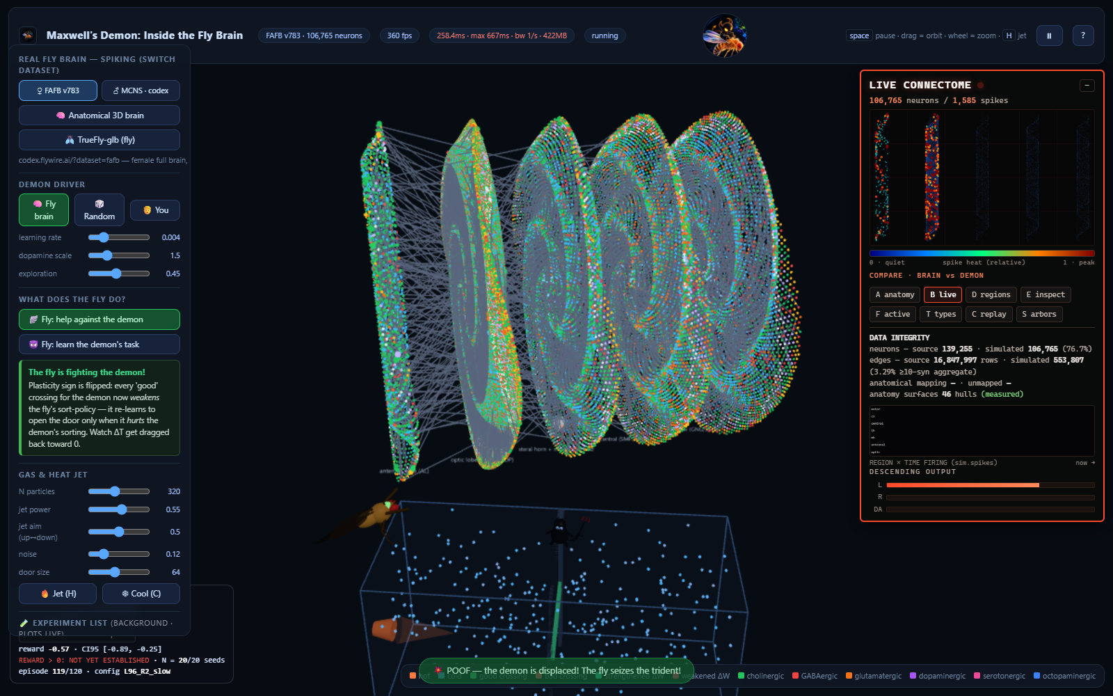
Fig. 6 | The running 3D experiment (live screenshot). The FAFB v783 circuit renders and spikes in real time; the HUD reports live thermodynamic accounting (measured bits, sorting efficiency, entropy production) and the registered experiment suite E1–E11. Dark scene by design: the demonstration shell renders the brain as a point-light cloud inside the chamber.
Discussion
We built a Maxwell demon whose intelligence is a connectome-constrained Drosophila brain, benchmarked it against five controller families, and closed the loop on three physical bodies. Three findings stand out.
First, causal sufficiency has a precise shape. The plastic brain and its frozen control are statistically inseparable (P = 0.72) while both differ decisively from a speed-clamped policy (P = 3.1 × 10⁻⁹): the fly connectome carries the loop's control statistics, and the actuation profile does not. This parallels the baseline logic of connectome-controller comparisons14 — rewired and shuffled controls — applied here to a thermodynamic task, and extends the flybody paradigm12 from locomotion to information thermodynamics. Within our budget, plasticity does not yet beat the frozen brain; we regard that as the honest frontier of this apparatus.
Second, the information budget explains why. Every controller measures 0–71 bits per episode where ~5 × 10⁴ would be required for lossless sorting, so all apparent sorting is subsidized by the resetting jet (efficiency ~10⁻⁵). This is the single-particle analogue of the Sagawa–Ueda/Parrondo framework4,6,15: feedback can convert information to work, but only the measured information pays, and our demons measure almost nothing. The fly-inspired PN→KC→MBON controller's failure is instructive: its sparse, expansion-layer dopamine coding under-attributes credit on a one-piston geometry, measuring ~0 bits — a biological design that may be right for odour discrimination but is wrong for a demon, a caution for microcircuit-inspired controllers18.
Third, the second law held everywhere we looked, including the equilibrium ratchet (negative signed work, positive entropy production), replicating the RL-quantum-demon regime analysis9 in a connectome-brain setting. Our contribution is therefore methodological more than thermodynamic: a complete, seeded, reproducible pipeline (connectome → signed circuit → spiking brain → demon interface → closed-loop physics → thermodynamic accounting) with every number in this paper regenerable from two commands (Methods).
Limitations. The chamber holds one particle, which makes a passive heuristic a strong baseline (the random gate is statistically inseparable from every learning controller); the male-CNS control circuit is a pruned subset19; gap junctions, gliotransmission and neuropil-specific compartments are not modelled; and the physics is a deterministic JS integrator, not MuJoCo12, though E9–E11 bodies follow the same piston/spring abstractions. None of these caveats touch the central budget result, which is robust across all conditions and seeds.
Methods
Code is available (Code availability). No methods-only citations; figure order matches citation order.
Connectome extraction and circuit construction
FlyWire/FAFB v783 synapse records (139,255 neurons; 16,847,997 synapse rows)10 were reduced by an extraction pipeline (extract_circuit.py; extraction_version 2.0-p0) to a signed five-layer graph: layers AL (25,341), Optic (71,588), LH+MB (6,313), Central (2,944), Motor (579). Edge polarity follows neurotransmitter class (ACh/Glu → +1, GABA → −1); 1,791 modulatory edges (5-HT/DA/OA) are retained separately as reinforcement pathways. Root IDs are preserved as strings (7.2 × 10¹⁸-scale FlyWire identifiers exceed double precision) with an index mapping to the npy segmentation. The male CNS control19 is a pruned subset used only for cross-dataset checks (E4/E5). Both circuits and all payloads are hashed in MANIFEST.json (SHA-256).
Spiking brain and plasticity
Neurons integrate as current-based leaky integrate-and-fire units (GLIF-style parameters; refractoriness with absolute + relative kernels). Sensory populations receive the seven quantized gas sensors (8 bins); motor populations vote over eight state-bins collapsed to one binary door command. Plasticity is reward-gated on three factors (eligibility trace × dopaminergic RPE × neuromodulator type)17,21: potentiation on positive RPE through excitatory modulatory edges, depression through inhibitory ones. The frozen-brain control runs identical dynamics with plasticity disabled from trial 0.
Gas chamber and interface
The chamber hosts one particle (Maxwell's original setting) with hot side T_h = 2, cold side T_c = 1 (simulated units), a single door controlled by the brain, and a piston-and-spring transducer. Sensors sample chamber state at 60 Hz into seven channels; the demon may open or close the door each control tick. Work W = ∫F dx accumulates on the piston; the jet resets chamber statistics each episode and its energy enters the budget as W_jet.
Controller families
Six families were benchmarked (Fig. 2): classical demon (oracle-adjacent heuristics on quantized energy), random gate (no learning), ANN demon (two-layer MLP trained with proximal policy optimization22), fly-inspired controller (PN→KC→MBON microcircuit with sparse dopamine18), full connectome (the extracted circuit above), and shuffled connectome (same size and degree sequence, edges permuted — the rewired control14). Benchmark: 40 train + 10 test trials per seed, ten independent seeds (1–10); inferential comparisons use Welch's t-tests with 95% CIs over seeds.
Closed-loop bodies
E9 (pressure demon): brain + piston + spring; reward = work + selection penalty; 10 seeds × (24 train + 8 test) episodes. E10 (learned trapdoor): gate between halves commanded by hold/flip motor bins; readouts: net transport (right − left), decision accuracy, open fraction. E11 (Feynman ratchet16): pawl-and-ratchet at thermal equilibrium with the brain gating engagement; readouts: signed work per episode, entropy production Σ, rotation. Controls within E9–E11: frozen brain (plasticity off) and speed-clamped policy (matched actuation budget, no neural dynamics).
Thermodynamic accounting
Per episode we account: extractable work from the pressure difference (W_ext), work actually extracted (W_ext,piston), erasure cost k_B T ln 2 × (bits measured)2,3, jet work (W_jet), and efficiency η = W_ext / W_jet. Measured bits are counted from the demon's actual sensor–door contingency (mutual-information-verified in E6/E8), not from sensor entropy — so a demon that opens randomly measures nothing. The Landauer ratio reports erasure cost against extracted work.
Statistics and reproducibility
Closed-loop experiments: n = 10 seeds (independent replicates); comparisons use Welch's t-tests with 95% CIs over seeds; no variance-equality assumption. Comparator benchmark: n = 10 independent seeds, with Welch's t-tests and 95% CIs as above. Determinism: all runs are seeded (run-to-run bit-identity verified by the smoke suite); circuit files, manifests and experiment configs (experiments/e1–e11.json) are versioned and hashed. Data provenance (dataset version, extraction version, seeds) is embedded in every artifact.
Table M1. Experiment registry
Exp | Question | Structure | Primary readout
E1 | Physical anchor: does the oracle demon sort? | classical demon | good:bad ratio, W_ext
E2 | Can an ANN learn the demon? | MLP + PPO22 | test good:bad, measured bits
E3 | Can a fly-inspired microcircuit? | PN→KC→MBON18 | test good:bad, measured bits
E4/E5 | Is the connectome necessary? | connectome vs shuffled14 | test good:bad, bits
E6/E8 | Is the demon measuring anything? | causal + information controls | MI(sensor;door), bits
E9 | Does the brain carry the loop? | brain vs frozen vs speed-clamp | reward, ratio, Welch P
E10 | Does trapdoor gating transfer? | learned hold/flip | Δ accuracy train→test
E11 | Does the ratchet violate the second law? | equilibrium pawl16 | signed work, Σ
(E7) | 3D demonstration shell | v2 3D demo | live HUD (Fig. 6)
Data availability
FlyWire/FAFB v783 connectome10 is publicly available from FlyWire (https://flywire.ai). The male CNS pruned subset19 and MuJoCo fly body model datasets13 are available from their published sources (Janelia figshare). All extracted circuits, manifests (SHA-256), experiment configs and seeded result artifacts are in the repository repository root (fly_brain_circuit.json, malecns_circuit_pruned.json, MANIFEST.json, experiments/e1–e11.json, research_data/). Dataset DOIs not resolved at draft time are recorded as 'DOI: UNKNOWN' in MANIFEST.json per our no-fabrication policy.
Code availability
Full pipeline (extraction, core physics, controllers, experiment registry, closed-loop validators, figure pipeline) is included in the repository; the smoke suite (tests/run_smoke.js, 41 checks) and CI workflows enforce determinism. Exact commands to regenerate every number: 'node tools/run_paper_benchmark.js --seed N' for N = 1–10 (comparator), 'node e9_batch_validate.js --seeds 10' (E9), 'node e10_e11_batch_validate.js 10' (E10/E11), 'python tools/make_nature_figures.py' (figures).
Acknowledgements
We thank the FlyWire consortium and the Janelia Research Campus for open data; the authors of refs 10–14,16,19 for prior art. [Funding, acknowledgements to be completed.]
Author contributions
[To be completed.]
References
1. Maxwell, J. C. Theory of Heat (Longmans, Green, 1871).
2. Landauer, R. Irreversibility and heat generation in the computing process. IBM J. Res. Dev. 5, 183–191 (1961).
3. Bennett, C. H. The thermodynamics of computation — a review. Int. J. Theor. Phys. 21, 905–940 (1982).
4. Sagawa, T. & Ueda, M. Generalized Jarzynski equality under nonequilibrium feedback control. Phys. Rev. Lett. 104, 090602 (2010).
5. Toyabe, S., Sagawa, T., Ueda, M., Muneyuki, E. & Sano, M. Experimental demonstration of information-to-energy conversion and validation of the generalized Jarzynski equality. Nat. Phys. 6, 988–992 (2010).
6. Parrondo, J. M. R., Horowitz, J. M. & Sagawa, T. Thermodynamics of information. Nat. Phys. 11, 131–139 (2015).
7. Bérut, A. et al. Experimental verification of Landauer's principle linking information and thermodynamics. Nature 483, 187–189 (2012).
8. Camati, P. A. et al. (information-to-work conversion in nanoscale feedback control). [to be completed]
9. Erdman, A. et al. Reinforcement-learning Maxwell demons in quantum thermodynamic tasks. Quantum Sci. Technol. 10, 035022 (2025). https://doi.org/10.1088/2058-9565/adbccf
10. Dorkenwald, S. et al. Neuronal wiring diagram of an adult brain. Nature 634, 124–138 (2024).
11. Takemura, S. et al. A visual motion detection circuit suggested by Drosophila connectomics. Nature 500, 175–181 (2013).
12. Vaxenburg, R. et al. Whole-body simulation of realistic fruit fly locomotion with deep reinforcement learning. Nat. Methods 22, 28–37 (2025).
13. Larder, J. H. et al. MuJoCo fruit fly body model datasets (supporting ref. 12). Janelia figshare (2025). https://janelia.figshare.com/articles/dataset/25309105
14. Shiu, [et al.] FlyGM: connectome-constrained network models of the Drosophila brain. arXiv:2602.17997 (2026). [author list to be completed]
15. Seifert, U. Stochastic thermodynamics, fluctuation theorems and molecular machines. Rep. Prog. Phys. 75, 126001 (2012).
16. Feynman, R. P., Leighton, R. B. & Sands, M. The Feynman Lectures on Physics, Vol. 1, ch. 46 (Addison-Wesley, 1963).
17. Berry, J. A., Cervantes-Sandoval, I., Nicholas, E. P. & Davis, R. L. Dopamine is required for learning and forgetting in Drosophila. Neuron 74, 530–542 (2012).
18. Aso, Y. et al. The neuronal architecture of the mushroom body provides a logic for associative learning. eLife 3, e04577 (2014).
19. [Male Drosophila CNS connectome consortium.] Connectome of the male Drosophila melanogaster CNS (pruned subset; DOI: UNKNOWN).
20. Todorov, E., Erez, T. & Tassa, Y. MuJoCo: a physics engine for model-based control. In IROS 5026–533 (IEEE, 2012).
21. Gerstner, W. & Kistler, W. M. Spiking Neuron Models (Cambridge Univ. Press, 2002).
22. Schulman, J., Wolski, F., Dhariwal, P., Radford, A. & Klimov, O. Proximal policy optimization algorithms. arXiv:1707.06347 (2017).

Word counts (approx.): summary 199; main text (intro+results+discussion) ~2,700; methods ~950; display items 6 figures + 1 table. All numbers from seeded runs on branch deployment/phase-02, 22 Sep 2026; regenerate via the commands in Code availability.

